**Chapter 18 Programming Assignment**

By Reno Redaja

**Project 18.1**

Write a program that recursively sums all the digits in a given integer. Create a method based on the following method header:

public static int sumDigits(long num)

This method should recursively add up all the digits that make up the long num. The main() method should prompt the user to enter a number, then call the sumDigits() method to add up the digits in the number. The result should then be displayed to the user.

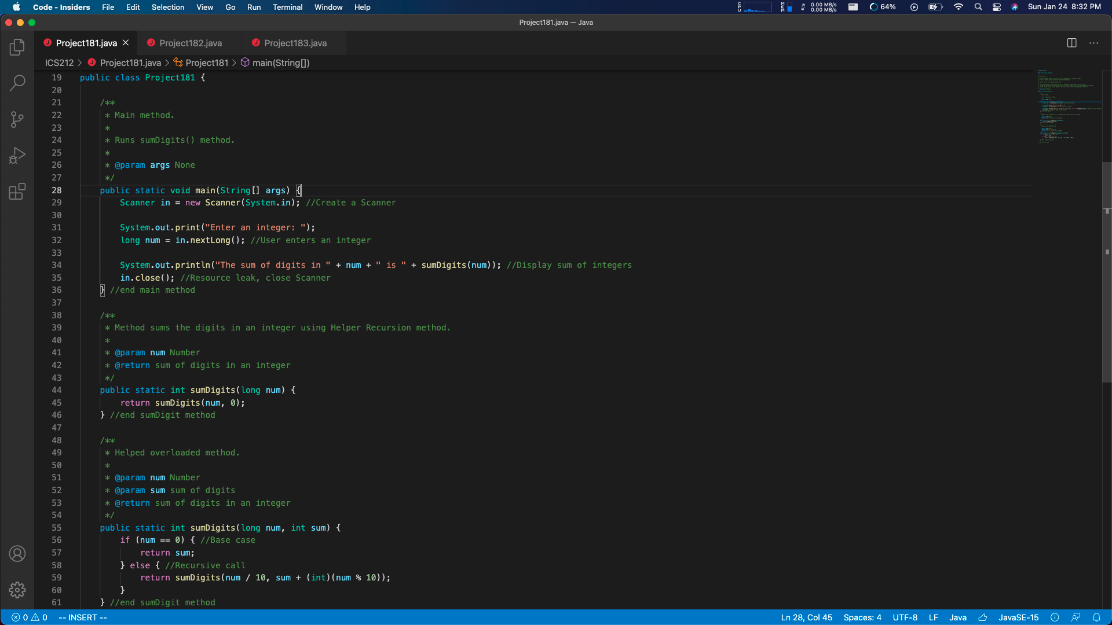

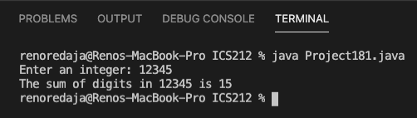

My program meets Project 18.1 requirements because it uses a recursive method to add all the digits a user has entered. The method I have created receives user input then prints out the sum of the digits entered. It also prints the example run for this program.

**Project 18.2**

Write a program that recursively counts the number of letters in a given word/phrase. Create a method based on the following method header:

public static int count(String s, char c)

This method should recursively count the number of times the character c occurs in the string s. The main() method should prompt the user to enter a word/phrase and a character, then call the count() method to count the occurrences of the character in the string. The count() method should not be case sensitive. The result should then be displayed to the user.

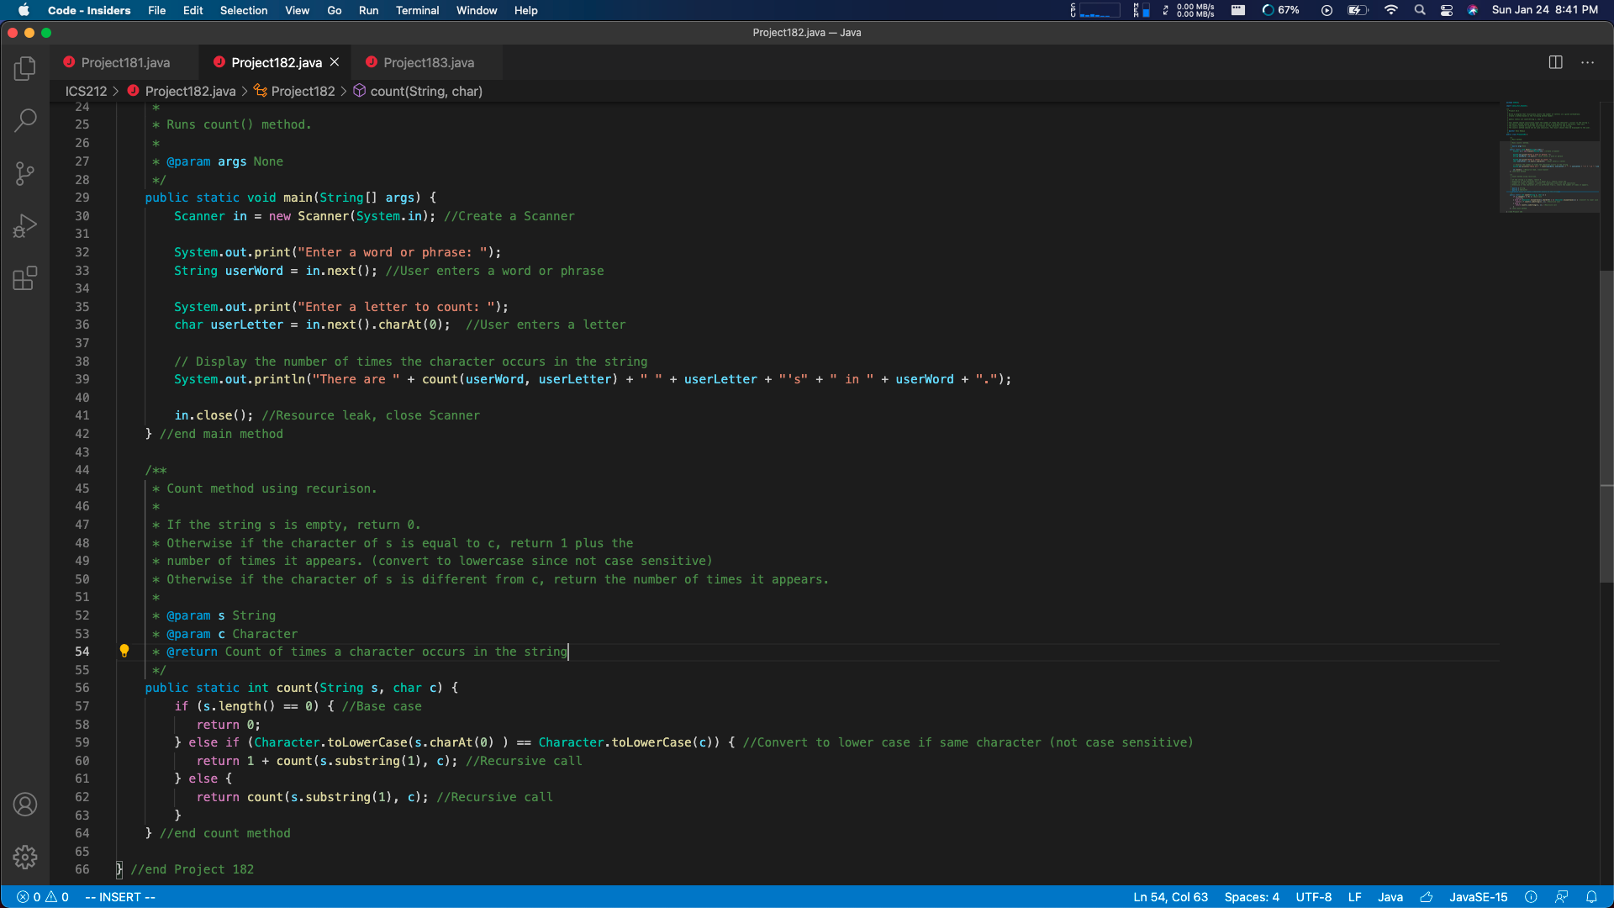

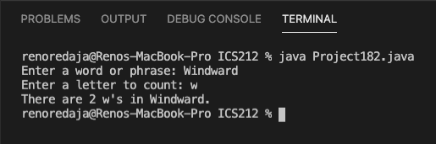

My program meets Project 18.2 requirements because it uses a recursive method to count the number of times a character occurs in a string entered by the user. It also prints the example run for this program.

**Project 18.3**

Write a program that recursively prints out characters in a triangle shape, such as:

*****

****

***

**

*

The main() method should prompt the user to enter a number of lines to print, and the character(s) to print. Then it should call your method to print out the triangle. For this project, you will determine what your method should return, if anything, and what parameters your method will need.  
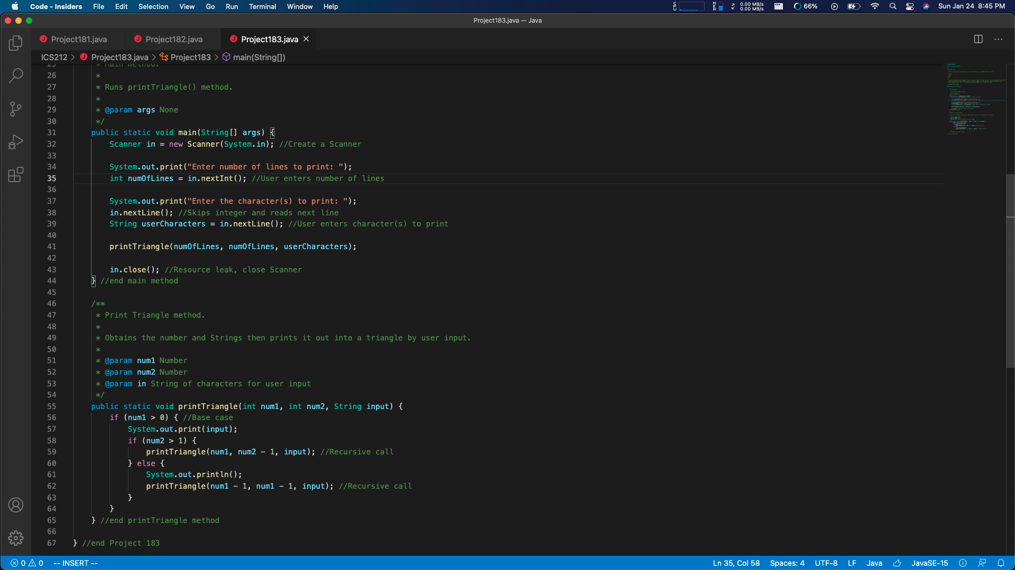  
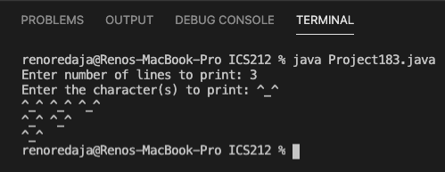

My program meets Project 18.3 requirements because it uses a recursive method to print out characters entered by a user into a triangle. It also prints the example run for this program.